SinkHole Attack in LEACH
Software Recommended: NetSim standard v14.4, Visual Studio 2022
Project Download Link:
https://github.com/NetSim-TETCOS/Sinkhole-Attack-in-LEACH-v14.3/archive/refs/heads/main.zip
Follow the instructions specified in the following link to download and setup the Project in NetSim:
https://support.tetcos.com/support/solutions/articles/14000128666-downloading-and-setting-up-netsim-file-exchange-projects
Introduction :
Leach(Low – Energy Adaptive Clustering hierarchy) is a MAC protocol which is integrated with clustering and a simple routing protocol in wireless sensor networks (WSN). The goal of LEACH is to lower the energy consumption required to create and maintain clusters to improve the lifetime of a wireless sensor network.
This Cross-Layer Protocol is implemented in NetSim in the MAC layer which involves ZigBee Protocol and the Network layer which involves DSR protocol. The clustering of sensors happens in the Network Layer and the cluster head election involves interacting with the MAC layer to obtain the remaining power of the sensors.

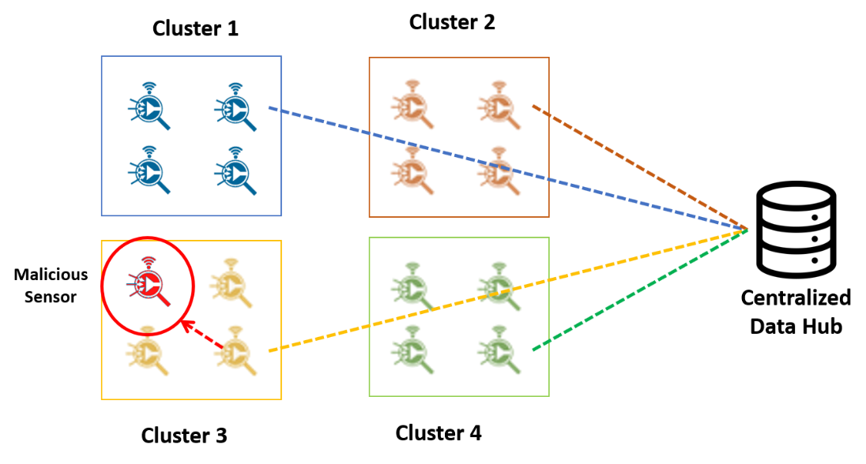
Figure 1: Network Scenario

Sinkhole Attack in Leach Overview:
1. In a smart city, sensor nodes are organized into four clusters, each with a cluster head. The cluster head collects data from nodes within the cluster and forwards it to a central sink node.

2. A malicious sensor node enters one of the clusters and advertises false battery information to become the cluster head instead of the legitimate node.

3. After becoming the cluster head, the malicious sensor node intercepts and redirects data packets from other nodes by responding to route requests, ensuring data passes through it.

4. Consequently, all data packets from the affected cluster are routed through the malicious node, which discards them, preventing any data from reaching the sink node.

Implementation:

A LEACH.c file is added to DSR Project.
- For this implementation of LEACH, the number of Clusters is fixed as 4 and all the 4 clusters are equal. If the user wants to change it, then he/she must also change the static routing for the Cluster Heads and the Cluster Element array accordingly.

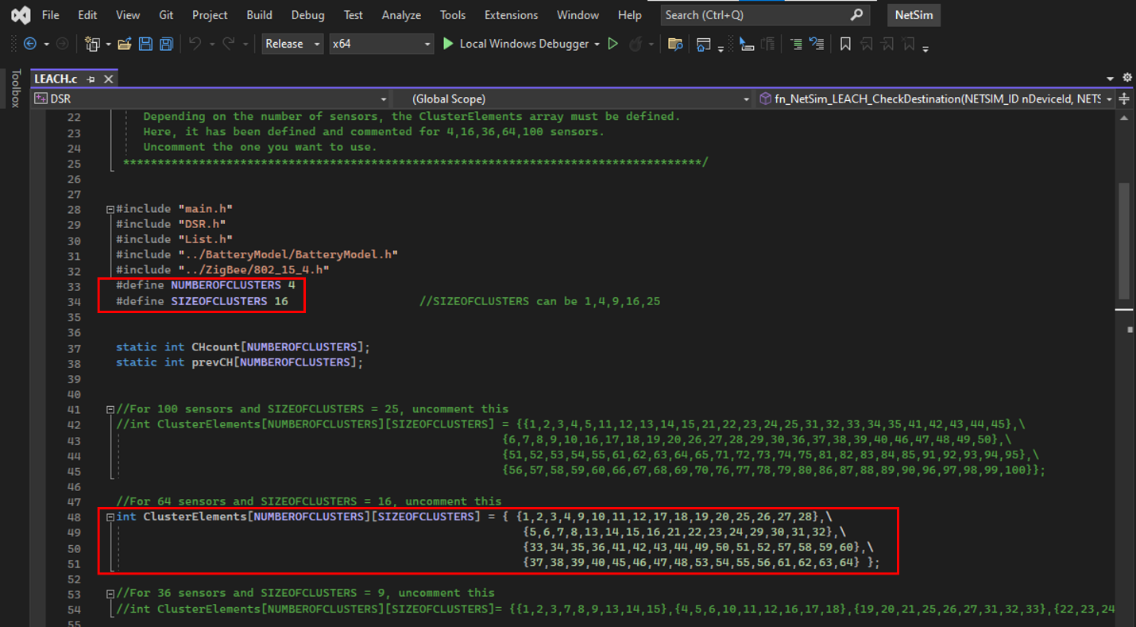Figure 2:Leach.c file in source code
- To make 4 equal clusters the number of sensors must be 4,16,36,64,100. Depending on the number of sensors, the Cluster Elements array must be defined. Here, it has been defined and commented on for 4,16,36,64,100 sensors. Uncomment the one you want to use.
The File contains the following functions:
fn_NetSim_LEACH_CheckDestination() // to check whether the current device is the destination or not.
fn_NetSim_LEACH_GetNextHop() // For getting the next hop device id.
fn_NetSim_LEACH_AssignClusterHead() // For electing the Cluster head based on Remaining energy.
fn_NetSim_LEACH_IdentifyCluster() // To determine the cluster to which a sensor belongs.
In this project, we are implementing a sinkhole attack on top of the LEACH project where a malicious node advertises false battery information to become a cluster head. Upon being elected as a cluster head, it attracts network traffic from all its cluster members and destroys the packets without forwarding them to the sink/base station.
A file malicious.c is added to the DSR project which contains the following functions:
- fn_NetSim_DSR_MaliciousNode() This function is used to identify whether a current device is malicious or not in order to establish malicious behavior.
- fn_NetSim_DSR_MaliciousProcessSourceRouteOption() This function is used to drop the received packets if the device is malicious, instead of forwarding the packet to the next hop.
You can set any device as malicious, and you can have more than one malicious node in a
scenario. Device IDs of malicious nodes can be set inside the fn_NetSim_DSR_MaliciousNode() function.
Note: By default, Malicious Node is set to 22 and NUMBER OF CLUSTERS – 4, SIZE OF CLUSTERS – 16, If changed Rebuild the Solution as shown below:

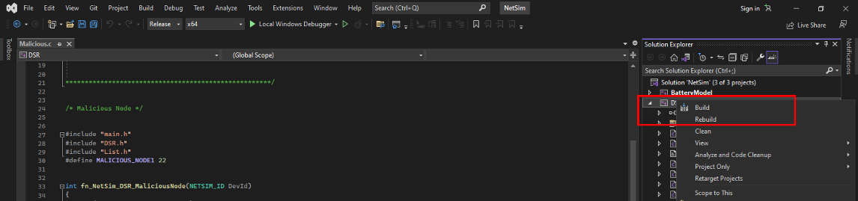
Figure 3:Solution Rebuild in source code
Right Click on the DSR project and Rebuild.

Example:

- The Sinkhole-in-LEACH-Workspace comes with a sample network configuration that is already saved. To open this example, go to Your work in the Home screen of NetSim and click on the Sinkhole-in-LEACH-Example. from the list of experiments.
- The network scenario consists of 64 sensors uniformly placed along with the SINKNODE as shown below.
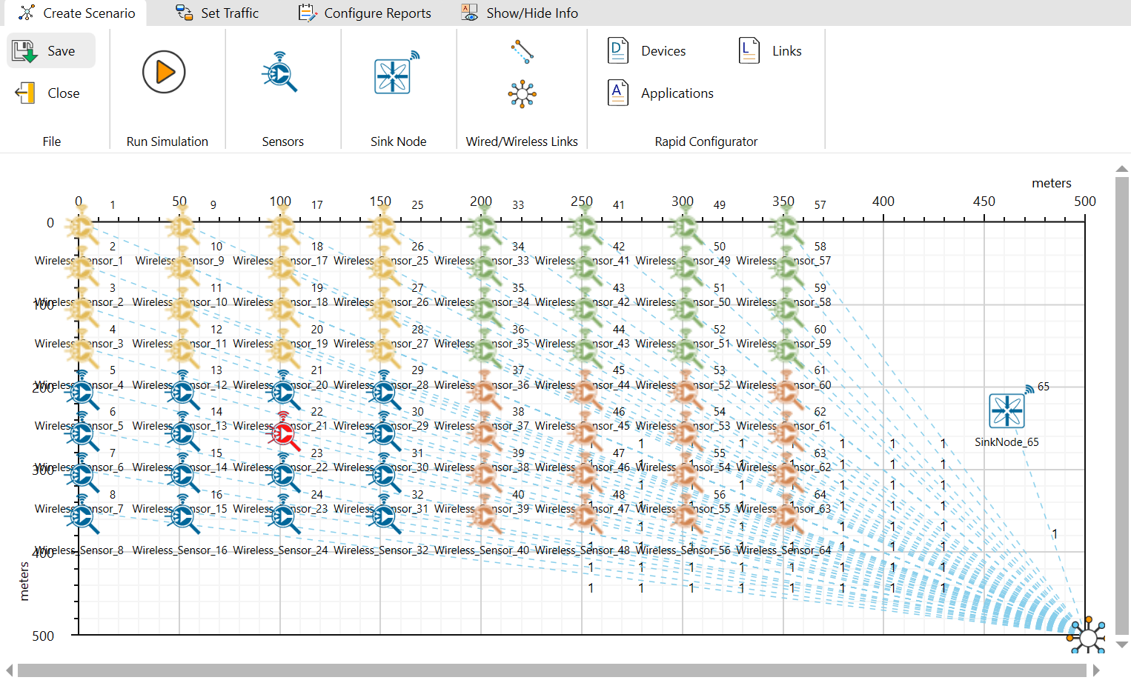
Figure 4:Network setup for Sinkhole attack in LEACH

- Run the simulation for 100 seconds.
Results and discussion:
- View the packet trace. You will note that the sensors directly start transmitting packets without route establishment since the routes are statically defined in LEACH. You will also note that the cluster heads keep changing dynamically in Clusters 1, 3, and 4. In cluster 2, the cluster members transmit packets to the malicious node (device id 22) since it advertises false battery information to become a cluster head.

- This can be observed in the Packet trace by applying filters to the Source_ID column by selecting only Sensor-5, 8,16,24,32. You will be able to see that the receiver id is sensor-22 throughout the simulation. All the nodes in Cluster2 are sending data packets to the malicious node (Sensor-22) since it is the Cluster Head
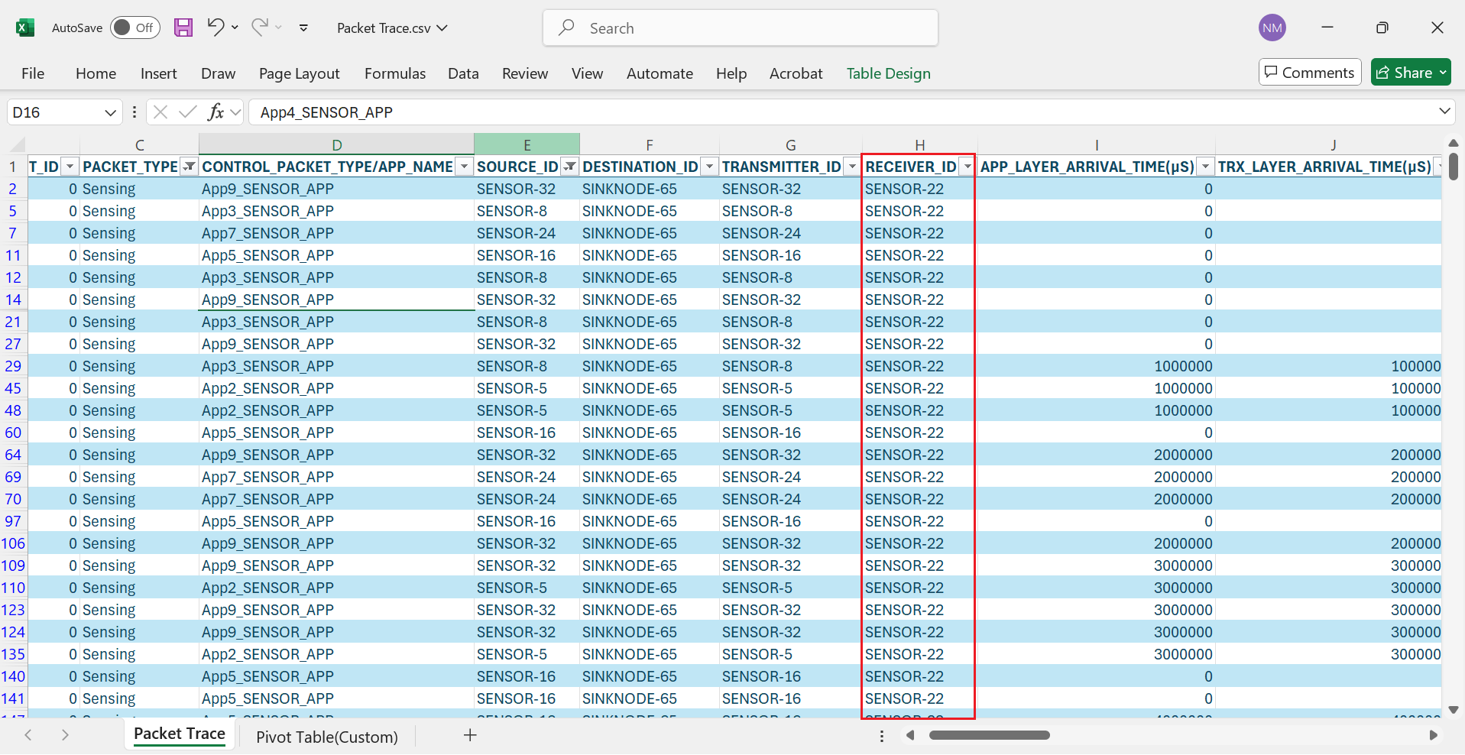
Figure 5: Packet trace file referring to malicious node reception of transmitted packets

- This will have a direct impact on the Application Throughput which can be observed in the Application Metrics table present in the NetSim Simulation Results window. The throughput for applications 2, 3, 5, 7 and 9 is zero since the source ids belong to cluster2 having a malicious node (device id 22).
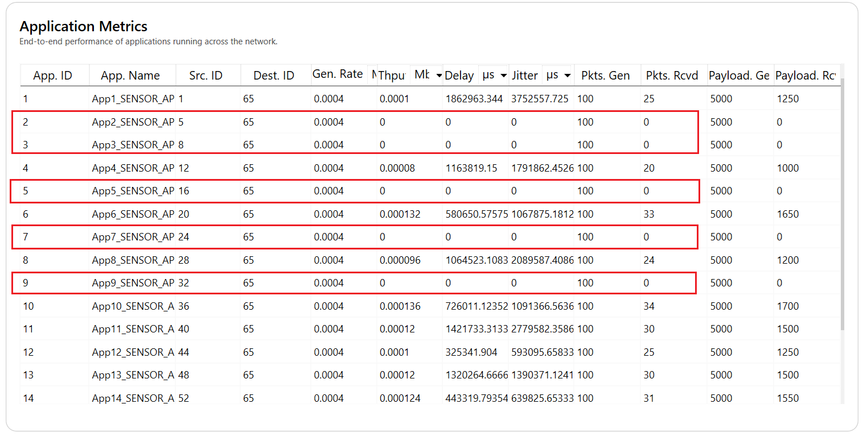
Figure 6: Simulation results window.

